Exercise 4

- List the first and last name of all employees whod raw less than or equal to $9000 and are not Programmers, Senior programmers or MultiMedia programmers.
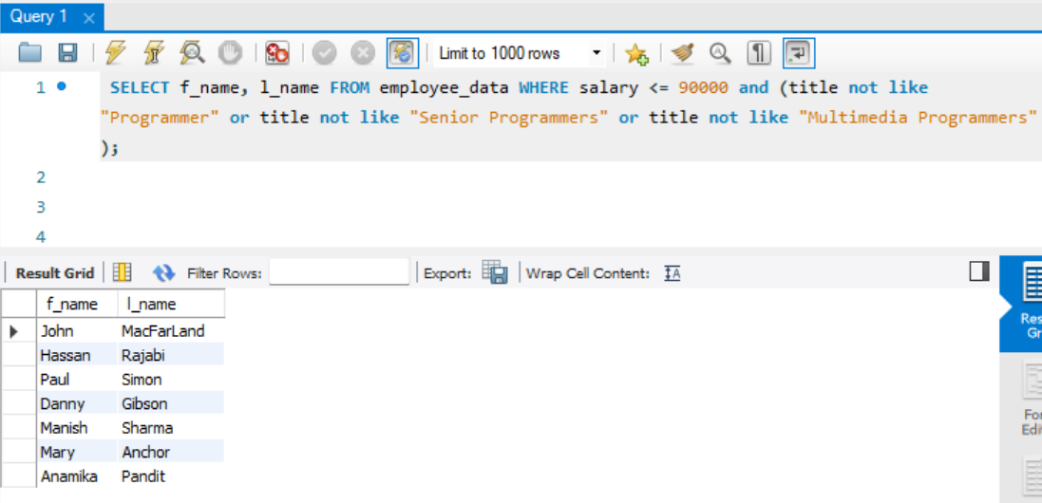
- What is displayed by the following statement?
Select l_name, f_name from employee_data where title NOT LIKE ‘%marketing%’ AND age < 30;

Returns all data that don’t have "marketing" on its title and have age less than 30

- List all ids and names of all employees between 32 and 40 years of age
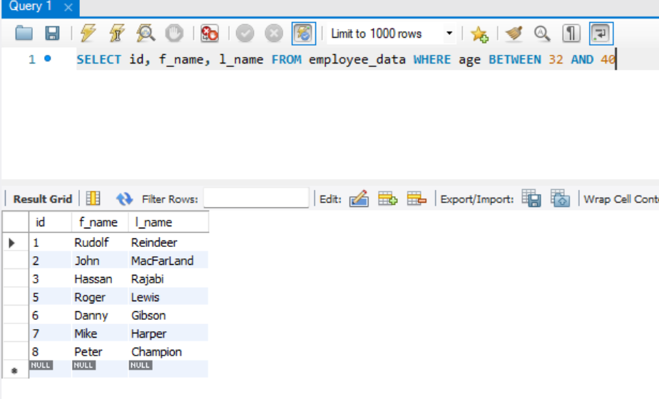
- Select names of all employees who are 32 of age and are not programmers.
